|  |  |
| --- | --- |
| Name (Sap Id): | Kalpita Shankhdhar (60004210164)  Akshata Sunil Dharmadhikari (60004220125)  Prerna Sunil Jadhav (60004220127) |
| Class: | T. Y. B. Tech (Computer Engineering) |
| Course: | Software Engineering Laboratory |
| Course Code: | DJ19CEL601 |
| Experiment No.: | 06 |

**FP ESTIMATION:**

1. **External Inputs (EI):**
   1. Add Lawyer
   2. Update Lawyer Information
   3. Add Client
   4. Update Client Information
   5. Add Case
   6. Update Case Information
2. **External Inquiries (EQ):**
   1. Query Case Details
   2. Query Client Information
   3. Query Lawyer Schedule
   4. Query Case Status
   5. Query Billing Information
3. **Internal Logical Files (ILF):**
   1. Lawyer Information
   2. Client Information
   3. Case Details
   4. Billing Records
   5. Legal Document Templates
4. **External Outputs (EO):**
   1. Generate Case Report
   2. Generate Legal Document
   3. Generate Client Invoice
   4. Generate Lawyer Billing Statement
   5. Generate Case Summary for Court Presentation
5. **External Interface Files (EIF):**
   1. Import Client Data
   2. Export Case Data
   3. Import Lawyer Schedule
   4. Export Case Updates to Court System
   5. Import Billing Information from Accounting Software

|  |  |  |  |  |  |
| --- | --- | --- | --- | --- | --- |
| **Information Domain Value** | **Count**  **(A)** | **Simple** | **Average**  **(B)** | **Complex** | **Total**  **(A x B)** |
| External inputs | 6 | 3 | 4 | 6 | 24 |
| External enquiry | 5 | 3 | 4 | 6 | 20 |
| Internal Logical Files | 5 | 7 | 10 | 15 | 50 |
| External Outputs | 5 | 4 | 5 | 7 | 25 |
| External interface files | 5 | 5 | 7 | 10 | 35 |
| Total: | | | | | 154 |

Value Adjustment Factors:

1. Does the system require reliable backup and recovery?

* 3 - The system requires reliable backup and recovery as it deals with important transactions and user data.

1. Are specialized data communications required to transfer information to or from the application?

* 4 - Specialized data communications are required.

1. Are there distributed processing functions?

* 3 - The platform may require distributed processing functions to handle high volume transactions.

1. Is performance critical?

* 5 - Performance is critical as the platform needs to handle real-time transactions and user interactions.

1. Will the system run in an existing, heavily utilized operational environment?

* 0 - The platform is a new product with no existing operational environments.

1. Does the system require online data entry?

* 4 - The platform requires online data entry for various transactions and user interactions.

1. Does online data entry require the input transaction to be built over multiple operations?

* 3 - Some functionalities may require input transactions over multiple screens.

1. Are the ILFs updated online?

* 5 - The ILFs are updated online as the platform deals with real-time transactions.

1. Are the inputs, outputs, files, or inquiries complex?

* 2 - Most of the inputs, outputs, files, and inquiries are simple.

1. Is the internal processing complex?

* 2 - The internal processing is not complex as the platform focuses on user interactions and transactions.

1. Is the code designed to be reusable?

* 3 - The code can be reused over multiple functionalities with minor modifications.

1. Are conversion and installation included in the design?

* 3 - Conversion and installation are included in the design.

1. Is the system designed for multiple installations in different organizations?

* 4 - The system is designed to be easily installed in different organizations.

1. Is the application designed to facilitate change and ease of use by the user?

* 5 - The application is designed to be user-friendly and easy to use.

Hence **Σ (Fi) = 46**

The estimated number of FP is derived:

**FP estimated = count-total x [0.65 + 0.01 x Σ (Fi)]**

= 154 x [0.65 + 0.01 x 46]

= 154 x 1.11

= 170.94

Therefore, **FP estimated is 170.94 pm**

**WORD-BREAKDOWN STRUCTURE:**

|  |  |  |  |  |
| --- | --- | --- | --- | --- |
| **Task ID** | **Task Description** | **Estimated Person-Hours** | **Who Will Do the Job** | **Resources** |
|  | Requirement Analysis | 40 | Business Analyst | Requirements Documents |
|  | System Design | 60 | System Architect | Design Tools, Software |
|  | Database Design | 40 | Database Designer | Database Management System |
|  | UI/UX Design | 40 | UI/UX Designer | Design Tools |
|  | Lawyer Management Module Development | 150 | Software Developers | Development Tools, IDE |
|  | Client Management Module Development | 120 | Software Developers | Development Tools, IDE |
|  | Case Management Module Development | 130 | Software Developers | Development Tools, IDE |
|  | Billing and Invoicing Module Development | 100 | Software Developers | Development Tools, IDE |
|  | Document Management Module Development | 90 | Software Developers | Development Tools, IDE |
|  | Testing and Quality Assurance | 80 | QA Team | Testing Tools, Test Cases |
|  | Integration and System Testing | 60 | QA Team | Testing Tools, Test Cases |
|  | User Acceptance Testing | 40 | End Users | Test Cases |
|  | Documentation and User Manual Preparation | 60 | Technical Writers | Documentation Tools |
|  | Training and User Support | 40 | Training Team | Training Materials |
|  | Deployment and Go-Live | 40 | Deployment Team | Deployment Tools |
|  | Project Management and Coordination | 100 | Project Manager | Project Management Tools |

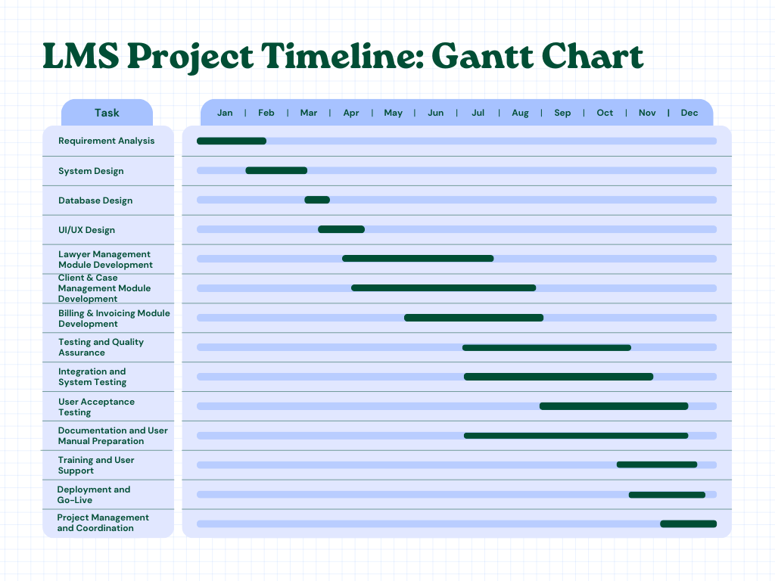**GANTT TIMELINE CHART:**